Below is the simplest and clearest IGV-based visualization guide
✅ Step-by-step installation
✅ How to organize files
✅ How to load tracks
✅ What buttons to click inside IGV
✅ How to interpret each visualization
✅ Interpretation of your deepTools plots

⭐ PART 1 — Install IGV (GUI)
Step 1 — Download IGV
Go to:
🔗 https://software.broadinstitute.org/software/igv/download
And download the respective file (For eg: exe file for windows)
Step 2 — Launch IGV
Double-click:
You now have the IGV window open.

⭐ PART 2 — Prepare Files for IGV
Your files are already generated. Here they are:
BigWig signal tracks
~/GSE104247/visualization/USF2_vs_INPUT_log2.bw
~/GSE104247/visualization/USF2.bw
~/GSE104247/visualization/INPUT.bw
Peak file
~/GSE104247/bam/USF2_peaks.bed
(Optional) BAM + BAI index files
Only needed if you want raw read alignment visualization.
~/GSE104247/bam/USF2_clean.bam
~/GSE104247/bam/USF2_clean.bam.bai
~
~/GSE104247/bam/INPUT_clean.bam
~/GSE104247/bam/INPUT_clean.bam.bai
You already have .bam.bai, which is required to view .bam in IGV.

⭐ PART 3 — Load These Tracks in IGV
Step 1 — Set Genome
In top left:
▶ Genome → Human → hg38
(Your data is hg38-aligned. IGV must match.)

⭐ Step 2 — Import Your Tracks
A) Load BigWig signal tracks
Menu:
File → Load from File…
Select these:
USF2_vs_INPUT_log2.bw
USF2.bw
INPUT.bw
IGV will show:
- USF2 (ChIP) – signal
- INPUT – background
- log2(ChIP/Input) – enrichment

B) Load Peaks (BED file)
Again:
File → Load from File…
Load:
USF2_peaks.bed
Peaks appear as narrow horizontal boxes.

C) (Optional) Load BAM files
If you also want to view raw reads:
USF2_clean.bam
USF2_clean.bam.bai
INPUT_clean.bam
INPUT_clean.bam.bai
IGV automatically uses .bam.bai.

⭐ PART 4 — Visualize Peaks
Step 1 — Choose a region
In IGV:
Go to a gene:
Search bar → "MYC"
Or randomly jump into peaks:
Right-click on your USF2_peaks.bed track →
→ "Jump to Peak"

⭐ PART 5 — What You Should See
1️⃣ USF2.bw (ChIP signal)
Tall peaks mean binding is strong.
2️⃣ INPUT.bw (background)
Should be mostly flat.
3️⃣ USF2_vs_INPUT_log2.bw
This is the most important track.
Positive values = enrichment = real ChIP peaks
Zero or negative = not enriched
4️⃣ USF2_peaks.bed
Should overlap high-signal regions.
This confirms your pipeline worked properly.

⭐ PART 6 — Interpret Your deepTools Plots
You shared two images:

📌 Plot 1 — Average Profile Plot
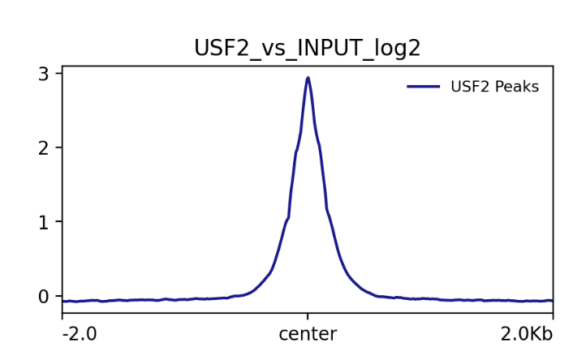

Meaning:
- X-axis: −2 kb to +2 kb around peak center
- Y-axis: log2(ChIP/Input) normalized signal
- The curve goes sharply upward near the center → strong USF2 binding
- Smooth symmetric shape → clean data, no artifacts
Interpretation for beginners:
✔ Peaks are real
✔ Enrichment is strong
✔ USF2 binds well-defined regions in this dataset
✔ Good signal-to-noise ratio

📌 Plot 2 — Heatmap
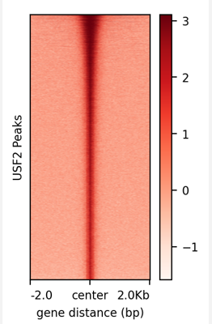

Meaning:
- Each row = one peak
- Color = log2(ChIP/Input)
- Bright red stripe in the center → high binding at peak center
- Light color in surrounding region → low background
Interpretation:
✔ Peaks are consistent
✔ Narrow peak shape → transcription factor–like binding (as expected)
✔ Data quality is good
✔ No weird patterns or noise

⭐ PART 7 — Very Simple Checklist (Beginner Friendly)
✔ Load 3 BigWigs
- USF2
- INPUT
- log2 ChIP/Input
✔ Load BED peaks
- USF2_peaks.bed
✔ Zoom into peaks
- Should see strong USF2 signal
- INPUT track should be flat
- log2 track clearly positive at peaks

